Software Requirements Specification (SRS) Document

ICanCare Cancer Cases Management System

1. Brief Problem Statement

The ICanCare Cancer Cases Management System is designed to facilitate seamless collaboration between patients and doctors in managing medical cases. The system allows patients to manage their cases, add doctors, upload prescriptions, receive AI-generated case summaries, and communicate in real time. Doctors can review cases, accept patient requests, and interact via chat. The primary doctor of the case can schedule meetings among doctors and patients of the case.

2. System Requirements

Technologies: MERN (MongoDB, Express.js, React.js, Node.js) stack, deployed on Azure.
- API Documentation: Swagger for generating and testing API documentation.

AI Integration: AI-based case summary generation.
- Payment Integration: Implementation of a secure payment system.

3. Users Profile

Patients: Users managing medical cases, uploading documents, and communicating with doctors.

Doctors: Medical professionals handling patient cases and interacting in real time. Primary doctors handle the meetings among the doctors and patient of the case.
- Admin Doctors: Doctors with administrative privileges can manage doctors, and check their ratings and reviews.

4. Feature Requirements (Use Cases)

No | Use Case Name | Description | Release
1. | Administration | Admin can review and approve doctor registrations, can monitor doctor ratings and feedback. | R1
2. | User Authentication and Access | Users can log in/register as a patient or doctor through the landing page | R1
3. | View and Manage Profile | Users can view and update their profile details including name, contact information, and other relevant data | R1
4. | View Patient Dashboard | Patients can see their details, ongoing cases, and the calendar which contains all the meetings that are related to the patient. | R1
5. | View Doctor Dashboard | Doctors can see ongoing cases and new case requests, discussions(forums) among the doctors and the calendar which contains all the meetings that are related to the doctor. | R1
6. | Manage Patient Case | Patients can view case details, upload documents, and view recommended medications in the chat. | R1
7. | Manage Doctor Case | Doctors can view case details, prescribe medications, recommend tests and participate in chats. | R1
8. | Search and Filter Doctors | Patients can search for doctors based on speciality, and location, can also sort the patients based on the ratings of the doctor. | R1
9. | Add Doctor to Case | Patients can invite doctors to their cases after searching/filtering. | R1
10. | Accept or Decline Case Requests | Doctors can review and accept/decline patient invitations | R1
11. | Real-time Chat Room | Enables group communication between doctors and patients for a case | R1
12. | Give feedback to doctors | The patients can give feedback and ratings to the doctors belonging to their case. | R1
13. | Schedule Meeting | The primary doctor schedules the meeting among the doctors including him and the patient. | R1
14. | Send Email Notifications | Automatic emails containing the link for the meeting will be sent to the doctors and patients of the case.  Also the meeting link will be sent in the chat. | R1
15. | View Calendar | Integrated calendar system for patients and doctors to track all scheduled appointments. | R1
16. | Doctor Forum | The doctors can discuss among themselves using forums. | R1
17. | Generate AI Case Summary | AI creates a summary of case-related chats and reports. | R2

5. Use Case Diagram

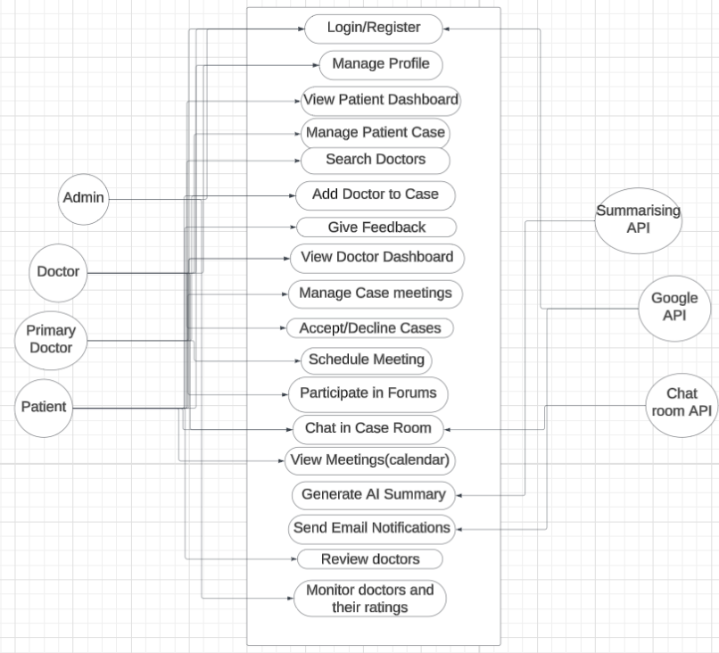

6. Use Case Descriptions
Use Case No. | Use Case Name | Overview | Actors | Precondition | Flow | Postcondition
UC-01 | Administration | Administrators manage doctor registrations and monitor feedback. | Admin | Admin is logged in to the system. | Admin logs into the admin dashboard. Admin reviews pending doctor registration requests. Admin approves or rejects doctor registrations.  Admin reviews doctor ratings and feedback. Admin takes appropriate actions based on feedback. | Doctor registrations are processed, and feedback is monitored.
UC-02 | User Authentication and Access | Users can register and log in to the system. | Patient  Doctor | User must provide valid credentials | User arrives at landing page, selects login/registration, System validates credentials, Grants access or shows error | User is either logged in or registration is pending approval.
UC-03 | View and Manage profile | Users can view and update their profile information | Patient  Doctor | User must be logged in | User navigates to profile section, Views current profile, Updates details, Saves changes | Updated profile information is stored
UC-04 | View Patient Dashboard | Displays patient’s details, ongoing cases, and meetings. | Patient | User is logged in as a patient. | Patient logs in, System display dashboard with case details and calendar with scheduled meetings. | Patient can navigate to other sections
UC-05 | View Doctor Dashboard | Doctors can view their assigned cases, requests, forums and calendar | Doctor | Doctor must be logged in | Doctor logs in, System displays dashboard, cases, case details and meetings in the calendar | Doctors can navigate to specific cases or requests, check meetings in the calendar
UC-06 | Manage Patient case | Patients can manage their case details and documents | Patient | Patient has an active case | Patient selects a case, System displays case details, Patient uploads documents, adds doctors to the case, views recommendations through chat | Case information is updated and stored
UC-07 | Manage Doctor Case | Doctors can manage case details they are involved in | Doctor | Doctor is assigned to the case | Doctor selects a case, System displays case details, Doctor provides recommendations | Medical recommendations are updated
UC-08 | Search and Filter Doctors | Patients can search for and filter doctors based on ratings, speciality and location. | Patient | Patient is logged in and has an active case | Patient navigates to add Doctor section. The patient enters search criteria (specialty, location).  Patient can sort results based on doctor ratings.  System displays matching doctors with their details.  Patient can select a doctor to view more information. | Patient has a filtered list of doctors to choose from.
UC-09 | Add Doctor to Case | AI creates comprehensive case summary | PatientPrimary Doctor | User is logged in as patient or primary doctor and has an active case. | User navigates to specific case. User selects add doctor option. User searches and selects a doctor from search results. System sends invitation to the selected doctor. System confirms invitation has been sent. | Invitation is sent to doctor, pending their acceptance.
UC-10 | Accept or Decline Case Requests | Doctors can review and respond to case participation requests. | Doctor | Doctor is logged in and has pending case requests. | Doctor navigates to pending cases section.  System displays list of pending invitations. Doctor reviews case details for invitation. Doctor selects either accept or decline button. System updates case status accordingly. | Doctor is either added to the case or the invitation is removed.
UC-11 | Real-time Chat Room | Enables communication between doctors and patients for a case. | Patient Doctor | User is logged in and part of an active case. | User navigates to specific case. User accesses chat section. User views previous messages. User can filter messages using tags. User types and sends new message. System displays message to all case participants. | Communication is recorded and accessible to all case participants.
UC-12 | Give feedback to doctors | Patients can rate and provide feedback on doctors. | Patient | Patient is logged in and has a case with at least one doctor. | Patient navigates to specific case. Patient selects doctor from the case. Patient clicks "Provide Feedback" option.  Patient enters rating and feedback text. Patient submits feedback.  System stores feedback and updates doctor's rating. | Doctor's feedback and rating are updated in the system.
UC-13 | Schedule Meeting | Primary doctor can schedule meetings with patients and other doctors. | Primary Doctor | User is logged in as primary doctor for a case. | Primary doctor navigates to specific case. Doctor selects schedule meeting option.  Doctor inputs meeting details (date, time, participants).  Doctor confirms meeting schedule. System generates Google meeting link. System sends notifications to all participants. | Meeting is scheduled and notifications are sent.
UC-14 | Send Email Notifications | System automatically sends email notifications for meetings. | System | A meeting has been scheduled or another notification trigger occurs. | Triggering event occurs (meeting scheduled, doctor added, etc.). System generates email content with meeting link. System sends emails to all relevant participants. System also sends meeting link in the case chat. System logs notification delivery. | All participants receive email notifications and chat messages.
UC-15 | View Calendar | Users can view their scheduled appointments and meetings. | Patient  Doctor | User is logged in | User navigates to calendar section. System displays calendar with all scheduled meetings. User can view details of specific meetings.  User can navigate between different time periods. | User has viewed their scheduled appointments.
UC-16 | Participate in discussions through doctor forum | Doctors can communicate via private forums. | Doctor | Doctor is logged in. | Doctor navigates to forums section. Doctor selects existing discussion or creates new topic. Doctor reads previous messages or posts new message. Doctor can discuss cases with other doctors. Doctor can arrange board meetings through forums. | Doctor has participated in professional discussions.
UC-17 | Generate AI Case Summary | System creates AI-generated summaries of case information. | System | Case has sufficient data for summary generation. | User requests summary generation. System processes case data including chats and reports. AI analyzes content and creates comprehensive summary. System stores generated summary. | AI-generated summary is available for the case.

7. Conclusion

This document serves as a foundation for developing the Medical Case Management System. It provides detailed functional and non-functional requirements to ensure a secure, efficient, and user-friendly experience for both patients and doctors.

